2015

HVAF FALL 2015 EPICS Final Report

Adam Sanders & Chris McDonald

**Table of Contents**

Table of Contents pg 1-2

**Chapter 1: Introduction**

Problem Statement pg 3

Motivation and Rationale pg 3

Description of Customer and Developers pg 3

Overall Approach and Process Model pg 3

**Chapter 2: Requirements Specification**

Description of Functional and Non-functional Requirements pg 4

Assumptions and Constraints pg 4

**Chapter 3: Architecture**

Overview of High-Level System Architecture

System Services pg 5

System Structure pg 5

System Communication pg 5

Architectural Decomposition pg 5

**Chapter 4: Design**

User interface description pg 6 – 11

**Chapter 5: Implementation**

Selection of Implementation Language(s) pg 12

Coding Standards and Comments Used pg 12

Implementation Process and Distribution of Work pg 12

Organization of the Code Base pg 12

**Chapter 6: Quality Assurance and Testing**

Testing Methods and Approach pg 13

**Chapter 7: Project Organization and Management**

Organizational Structure pg 14

Detailed Roles and Contributions pg 14

Project Management Process pg 14

Weekly Status Reports pg 14-25

**Chapter 8: Future Work**

Future Work Description pg 26

**Appendix**

Source Code pg 27

Final Presentation Slides pg 27-31

Client Evaluation Form pg 32

Peer Evaluation pg 33

**Chapter 1: Introduction**

**Problem Statement:**

This semester Chris and I worked for the Hoosier Veterans Assistance Foundation (HVAF). We were tasked with updating the previous EPICs project to allow for the HVAF staff to have access to it. While the basic functionality of the program was more or less in place, we needed to add the user group to SQL so that they would have access. We would also update the code based on user feedback after adding the user group.

The final deliverable for this project is a more functional version of the previous project that allows for anyone within the user group to connect to the application. This application will also be tuned to user feedback.

**Motivation and Rationale:**

We believed that HVAF would be a good client based on feedback from both Dr. Linos and students who had previously worked with them. We were also both interested working for HVAF as we both believe that they do very important work for the local veteran community.

**Description of Customer and Developers:**

We worked with Mike Mullins of HVAF. Our team was composed of two members, Chris McDonald and Adam Sanders. Chris is a junior Computer Science student from Greenville, Indiana. Chris has worked for the Indianapolis based company Angie’s List as a developer. Adam is a senior Computer Science student from St. Louis, Missouri. He has worked for AT&T also as a developer.

**Overall Approach and Process Model:**

After setting up a way to remotely access the server on which the database was stored, we immediately began to work on allowing access for members of HVAF’s user group. Once we had that implemented we got a list from Mike detailing various issues they had run into when using the application, as well as a few additional features that wanted us to implement. We didn’t really have a uniform meeting time, but we would get together as needed to work on the project, and were able to contact Mike whenever we needed something clarified.

**Chapter 2: Requirements Specifications**

**Functional Features:**

We were first tasked with adding the HVAF user group to SQL, and giving them admin privileges, specifically the ability to read from and write to the database. Once this was complete we received several requested updates from Mike that detailed either a change within the code itself or a change to the database structure. These changes included adding several pieces of clothing, like winter shoes and undergarments, and modifying some of the text on the application for clarity, such as changing ‘M pants’ to ‘Male Pants’. The database changes we needed to make were slightly more involved. When the database was created, no key relationships were established to properly link the various tables. We set up a foreign key relationship linking all tables back to the personal information table. In the original implantation of the code, instead of updating a person’s information if changes were made their personal information would be deleted and replaced with all new information. This also meant that the data in all other tables, like the clothing item table for instance would also need to be deleted. We modified the way all tables other than the personal information table worked so that would be able to store multiple entries per person, which would allow for a record of past services requested by the veterans aided during HVAF’s Outreach program. The modifications to the database, meant that we had also modify the applications code to account for the changes.

**Assumptions and Constraints:**

We did a fairly good job of estimating the difficulty of most tasks in the project, the only thing we didn’t fully account for initially was the difficulty caused by using the code from the previous semester. While not terrible, the code could have been implemented better, and was certainly not implemented how either of us would have.

Our primary constraint for the project, as it usually is in EPICS, was time. There were several occasions where our progress on the project was delayed by things like breaks and work for other classes.

**Chapter 3: System Architecture**

**Overview of High-Level System Architecture**

System Services:

Our project involved updating an application that would allow users to track the services requested by veterans attending an Outreach event held by HVAF, as well as keeping record of which veterans were requesting specific serves.

System Structure:

Out project is comprised of two main components, the application and the database. The application itself is an executable program, created in visual studio, that allows users to enter information about veterans, including personal information as well as what services they request. The database is a SQL server database which stores all of this information.

System Communication:

The application and database connect to one another, using SQL connection strings in the application. These strings are executed by the database, to store new data or modify information stored within the database.

**Architectural Decomposition**

The system operates in a way that could be best described as a client/server relationship. Users run the application on a machine connected to HVAF’s internal network, which then allows them to connect to the SQL1 server which hosts the database.

**Chapter 4: Design**

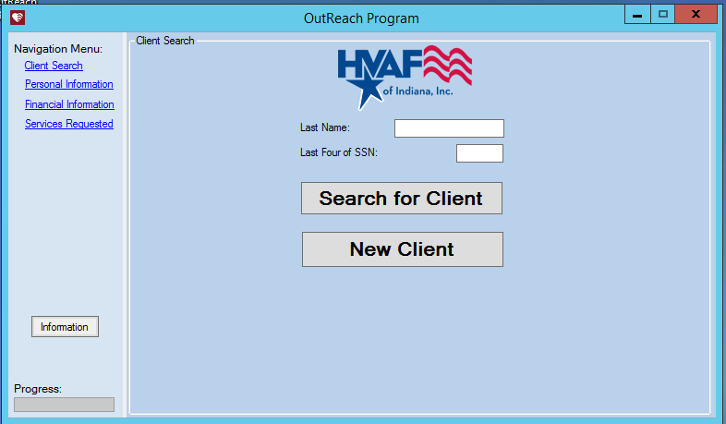

This is the home screen of the application. Users can search for a previous client by enter that client’s last name and the last four digits of the clients SSN.

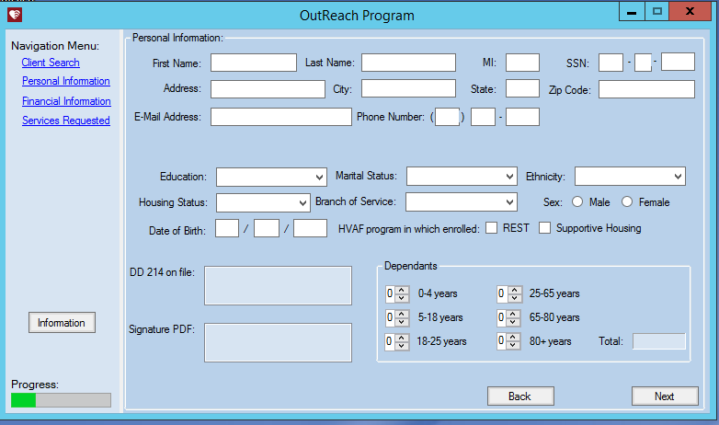

The next screen of the application is the personal information screen. This page will be displayed regardless of if this is a new client or a previous client, though if the client is a previous client that has been searched for, all fields will be pre-populated with their information.

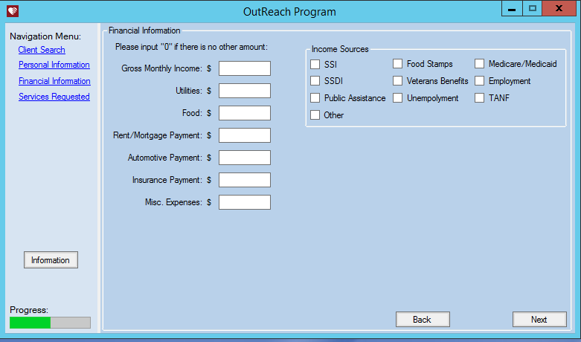

The financial information screen is the next screen that will be displayed to the user. Like the previous screen this will also be shown if a previous user is searched for, and again it will be pre-populated based on the stored information about the client.

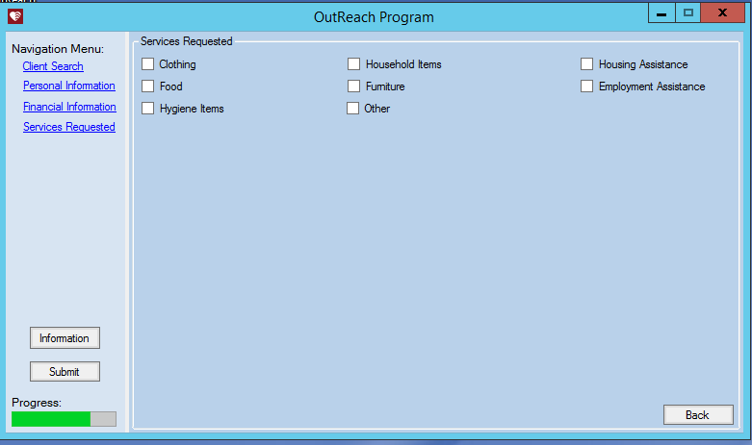

This screen has several important items, the check boxes are either toggles, like is the case with food and a few others, or open new windows that allow for more detailed selection, as is demonstrated with the clothing screenshot below. The information button on the left-hand side of the screen provides a screen that can be printed to show volunteers what items they need to gather, such as clothing, for the veterans. Finally the submit button submits all the data and stores it in the database. Demonstrations of these features are also shown below

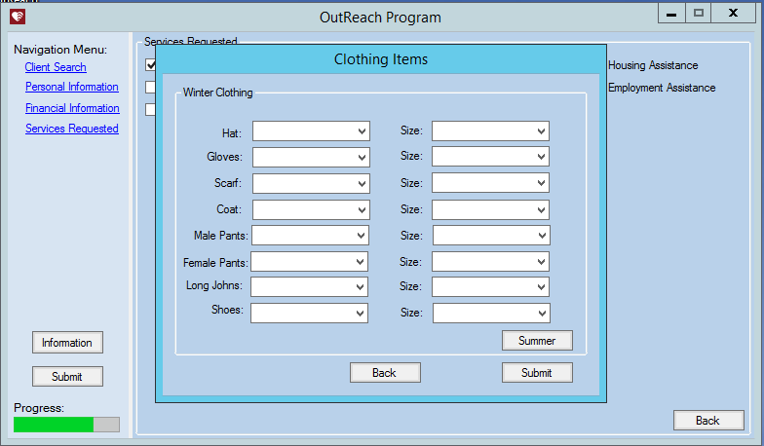

This is the above mentioned clothing page. The drop downs are populated with relevant sizes, types, etc. The Summer button above the submit button, switches the clothing to Summer types of clothes. Clothing was the only one of these that we modified, so if you would like to see screenshots of the other screens, please see the previous report.

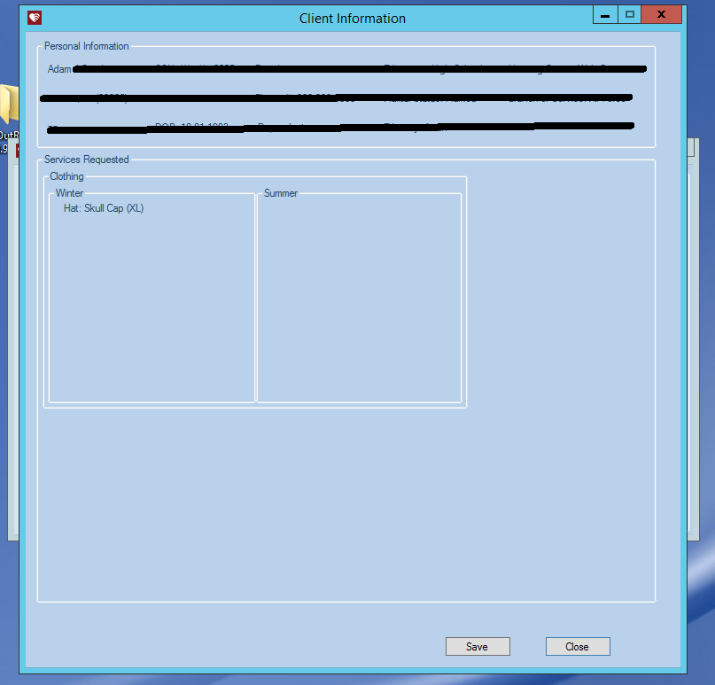

This page details all of the requested services, and it is intended to be printed to show volunteers what items and services the veteran has requested.

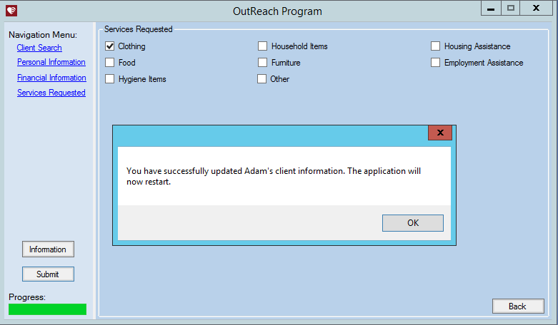

Once the submit button has been pressed, this pop-up is shown to confirm to the user what has just happened. Clicking ok on this prompt will take the user back to the screen shown in the first screenshot.

**Chapter 5: Implementation**

**Selection of Implementation Language(s)**

We did not really have a choice in languages as the code was already implemented in Visual Basic, and the database was already implemented in SQL Server. However, we were both familiar with both of these, so this was not an issue.

**Coding Standards and Comments Used**

We did our best to keep to the same conventions established in previous code. The main change we made was updating the database to include keys, which is almost always best practice. We also documented the store procedure we wrote to delete a person and all their records from the database.

**Implementation Process and Distribution of Work**

To implement our project we would work on the application code on one of our computers, and then move the executable to the SQL1 machine using either TeamViewer or LogMeIn (two remote desktop applications). We would then test whatever changes we had made.

The work was fairly evenly distributed. Adam handled the vast majority of communication with Mike, the client. Later in the semester, Adam began focusing more on database updates and testing of the updated executable, while Chris would modify the code to implement any changes to the database. While we did not have regular meetings scheduled, we would meet as needed.

**Organization of the Code**

We did not modify the organization of the code, so it will be the same as in the previous report. The basic structure is the application code is self-contained within a folder called ‘Outreach’ followed by a version number. The application’s executable file and the database are stored on the SQL1 server.

**Chapter 6: Quality Assurance and Testing**

**Testing Methods and Approach**

The majority of the testing we personally did was to ensure any new changes we made didn’t break anything that had been previously working. We tested this by simply trying to do what we had implemented in the application. The majority of the bug reports we received came from the HVAF staff when they were using the application, and we were able to recreate these errors, and then fix them. We again would attempt to reproduce the error after out fix, to ensure it no longer occurred. We don’t really have any screen shots of testing or code samples that were tested, because it was just running through the application that was picture above.

**Chapter 7: Project Organization and Management**

**Organizational Structure**

Since there were only two of us, we mutually agreed to be co-leads. Our duties were more or less the same, though Adam was the primary client liaison.

**Detailed Roles and Contribution**

Adam

Adam was a co-team lead. He was also responsible for contacting Mike, to both update him on the team’s progress and get new requirements to be implemented. Adam worked with Chris on implementing the changes Mike had requested. He was responsible for writing the weekly status reports and meeting weekly with Dr. Linos to update him on the team’s progress. Finally he was responsible for this final report.

Chris

Chris was also a co-team lead. He primarily worked with Adam on implementing the changes and updates Mike had requested throughout the semester.

**Project Management Process**

We had a very loose structure to the project. We did not have any set recurring meetings, and would simply meet as was necessary. We both know each other fairly well so communication was simply done through text.

**Weekly Status Reports**

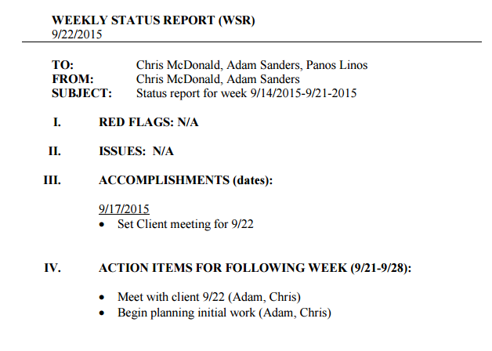

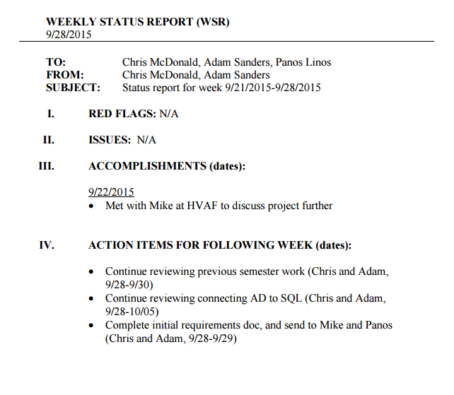

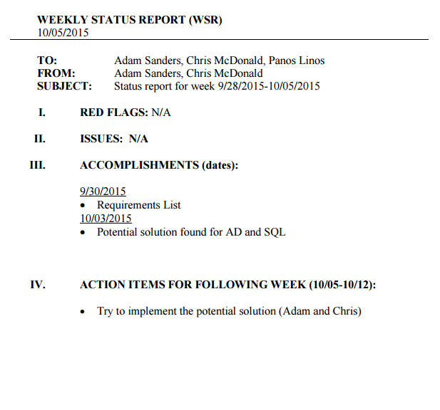

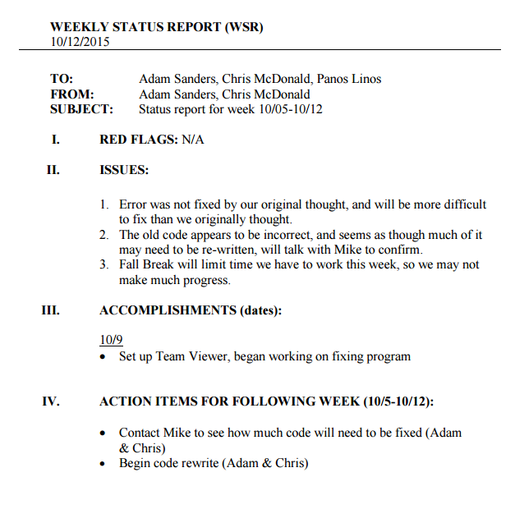

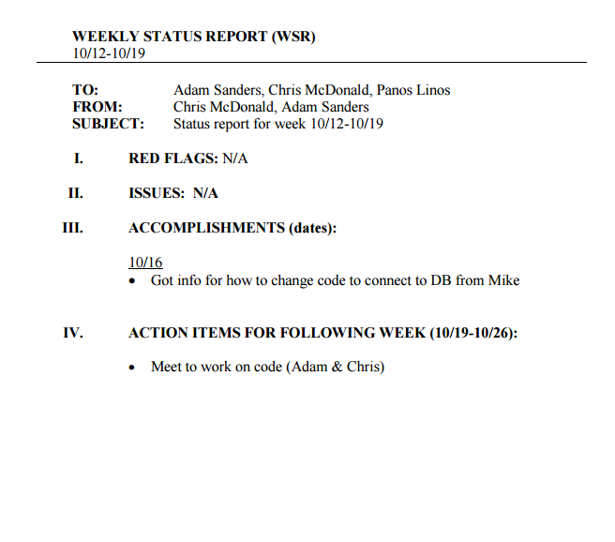

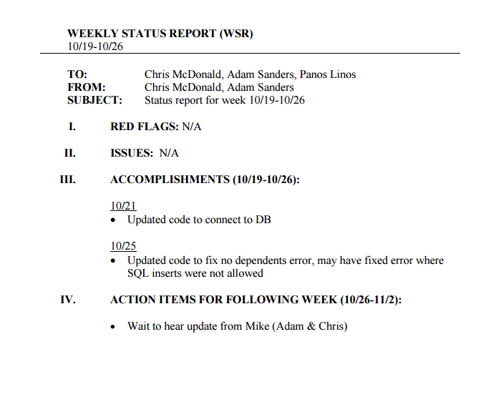

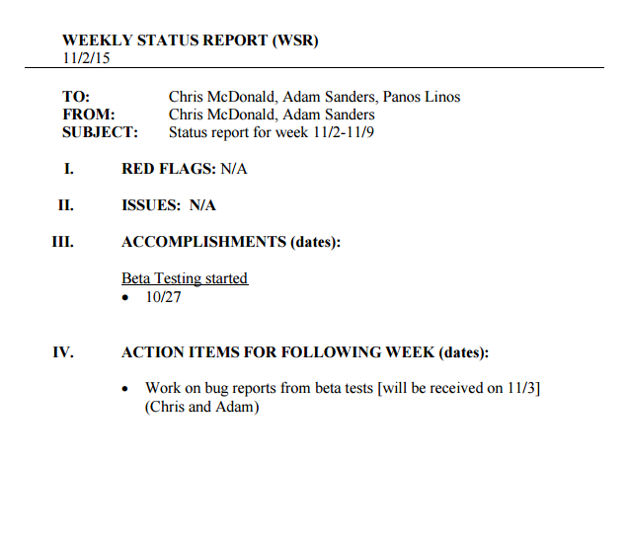

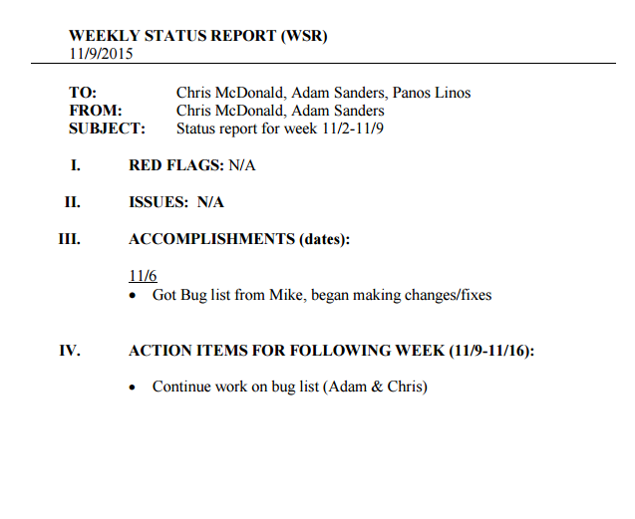

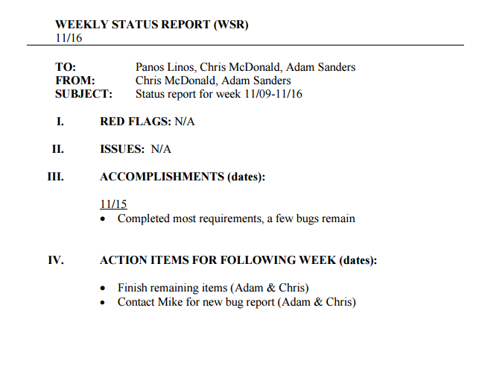

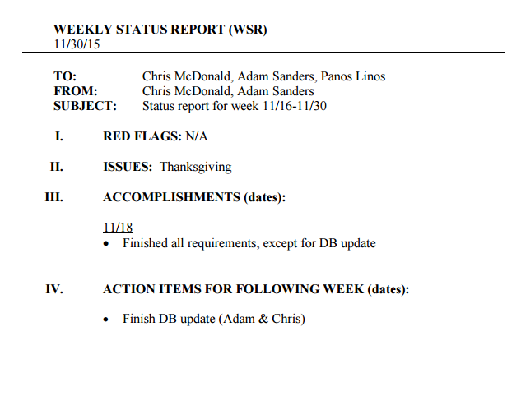

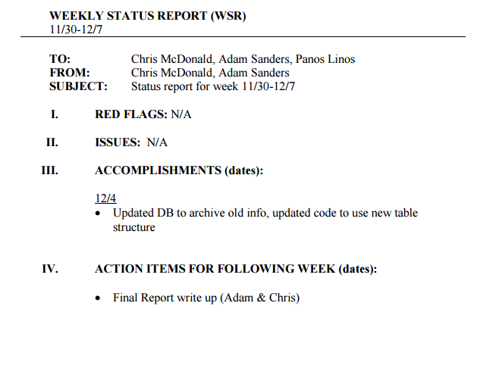

**Chapter 8: Future Work**

**Future Work Description**

While there are records of all services requested by a user now in the database, the only way to view old records is to visit the database itself. This should obviously be something that can be done in the application, but we simply didn’t have enough time to implement. There will also likely be new bugs found by the HVAF team that need fixing.

**Appendix**

**Source Code**

Rather than paste all of the source code here, I have provided [a link](http://epics.butler.edu/wp-content/uploads/2015/12/Outeach-1.0.zip) to it instead.

**Presentation Slides**

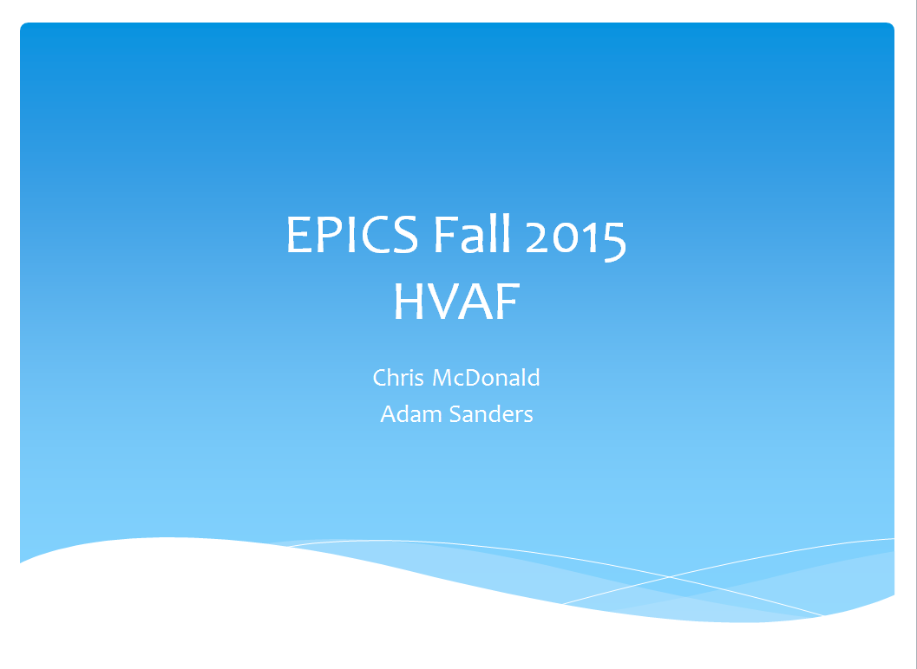

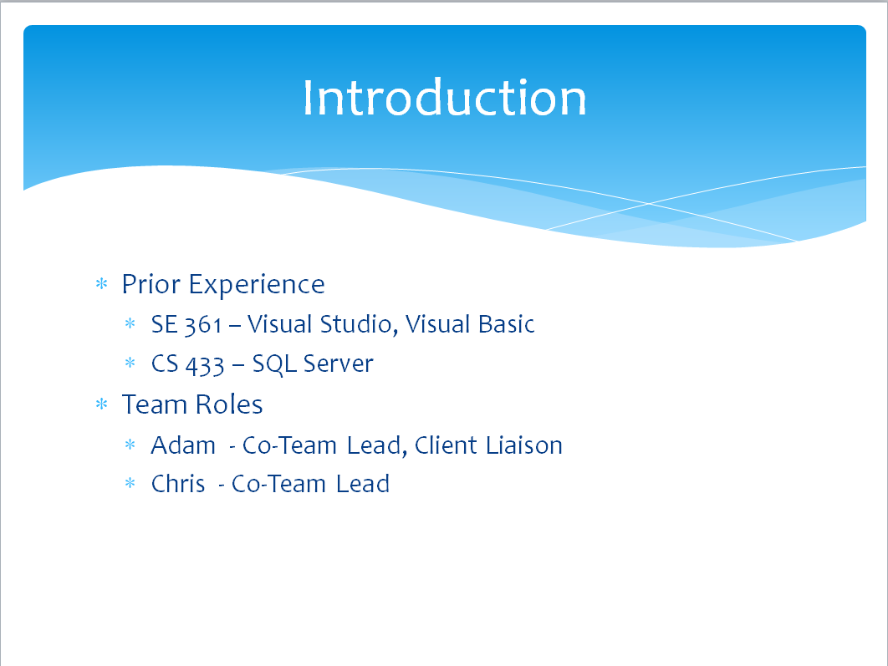

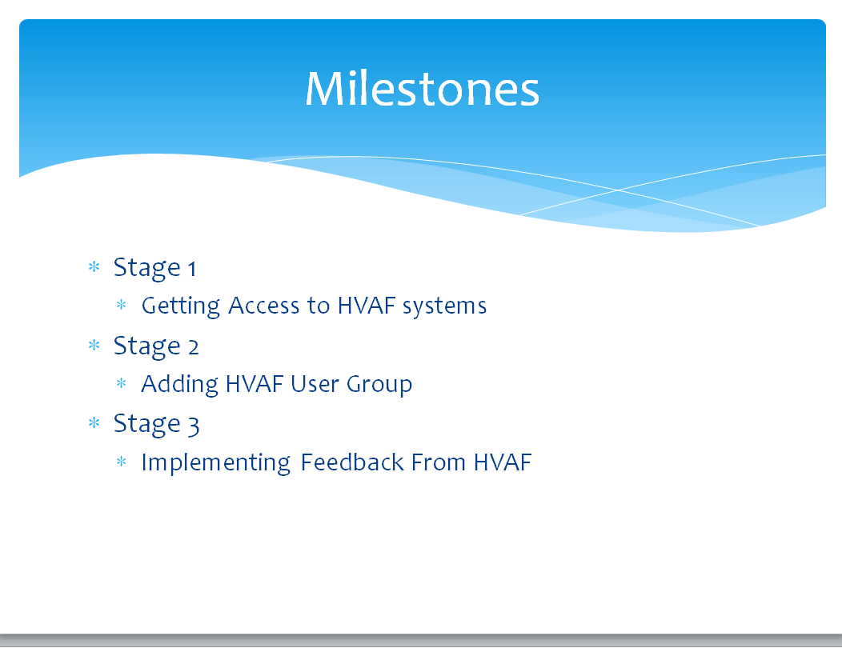

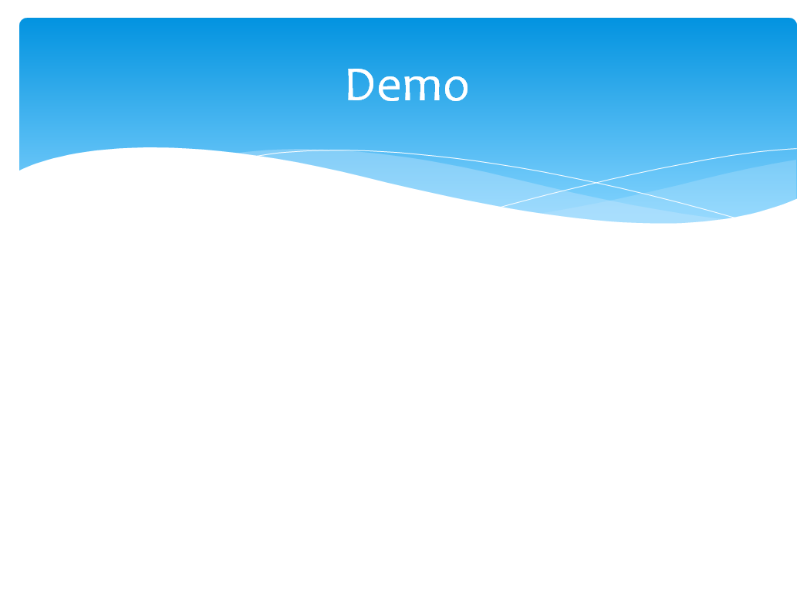

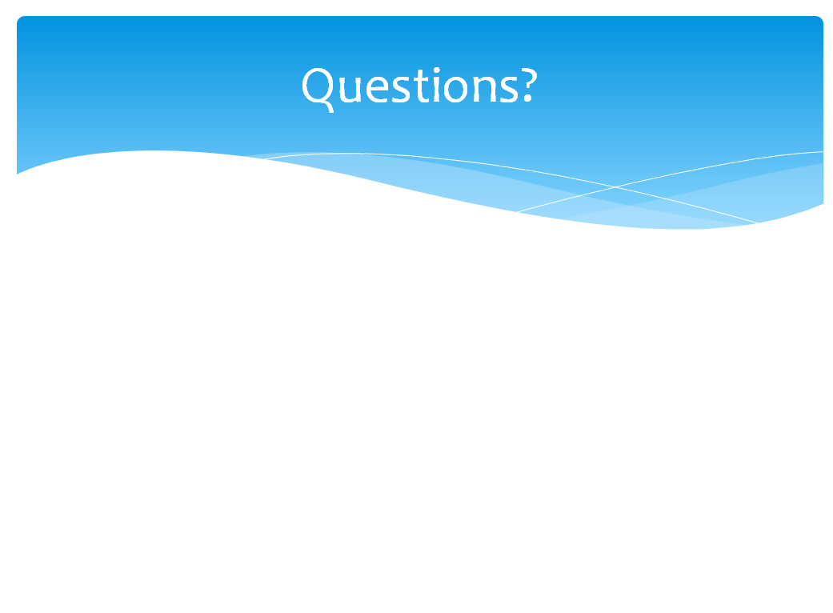

**Customer Evaluation Form**

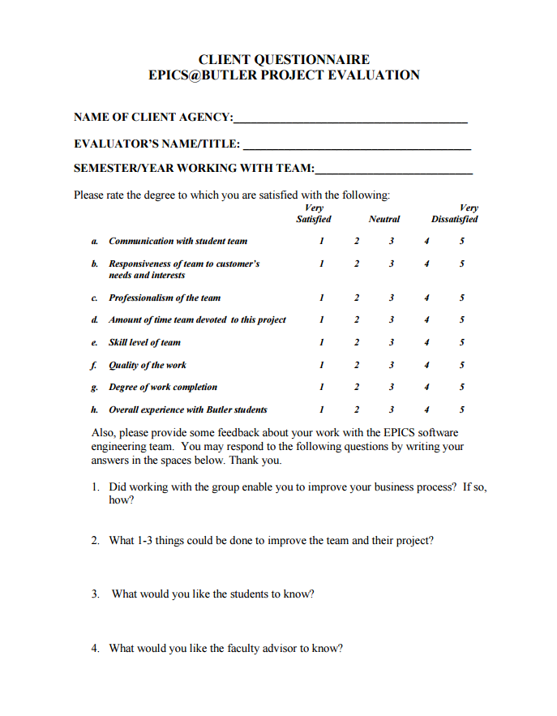

**Peer Evaluation**

Adam – Co-Team Lead

* Communicated with client
* Weekly Status Reports
* Final Report
* Worked through bugs reported by HVAF team

Chris – Co-Team Lead

* Worked through bugs reported by HVAF Team