horizontal line

**Ronald McDonald House Service Project**

MongoDB User’s Manual

**EPICS Spring 2017**

# OVERVIEW

MongoDB is an open source ***document*** database; a document in Mongo is a row in a standard table that contains **<field>: value** pairs. ***Collections*** in Mongo are tables in a standard db; Thus documents are stored in collections, which are stored in databases.

# GOALS

1. Mongo Databases
2. Define data types
3. Understanding documents
4. Converting Excel file to JSON format for DB insertion
5. Import Data Using MongoDB

# Databases

Create a Database

If a database does not exist, MongoDB creates the database when you insert data. Simply switch to a non-existent database

use <DBname>

And perform the following operation in the mongo shell

# Data Types

MongoDB has standard data types

* Double
* String
* Object
* String
* Object
* Array
* Binary
* Undefined
* ObjectId
* Boolean
* Date
* Null
* Regular Expression
* DBPointer
* JavaScript
* Symbol
* JavaScript (with scope)
* 32-bit integer
* Timestamp
* 64-bit integer
* Decimal128
* Min key
* Max key

Learn more about data types from the MongoDB webpage

<https://docs.mongodb.com/manual/reference/bson-types/>

# Understanding Documents

MongoDB stores information as BSON documents, which are a bit format used to store and retrieve data. Think of BSON as a binary representation of JSON (JavaScript Object Notation) documents.

JSON stands for JavaScript Object Notation, which is a **<field>: value** pair document used for structuring data.

BSON is an “extended version” of JSON, meaning it has greater functionality. Mongo can be run in **strict mode**, which forces all documents to adhere to JSON standards.

# Excel File to JSON for Database Insertion

* Create a file in Excel
  + Make sure the top rows are the data headings that will be used in the JSON data file
* Save the file as a .csv, or comma separated value file type
* Go to [http://www.convertcsv.com](http://www.convertcsv.com/csv-to-json.htm)
* Select the CSV to JSON header
* Scroll to the bottom of the page and select choose file in the second of two “choose file” boxes
* Navigate to the location where the created CSV file was saved
* Select the file and click on the conversion you would like (JSON, Keyed JSON, JSON array or JSON Column Array)
  + In this case, we want “CSV To JSON”
* Once the site is done working, click the “Download Result” button below the “Result Data” box

**Data Insertion**

There are two ways to import data into a mongo database. The two methods will be explained below.

**1: Mongoimport Method**

* 1. While using CMD, navigate to the directory where Mongo has been installed

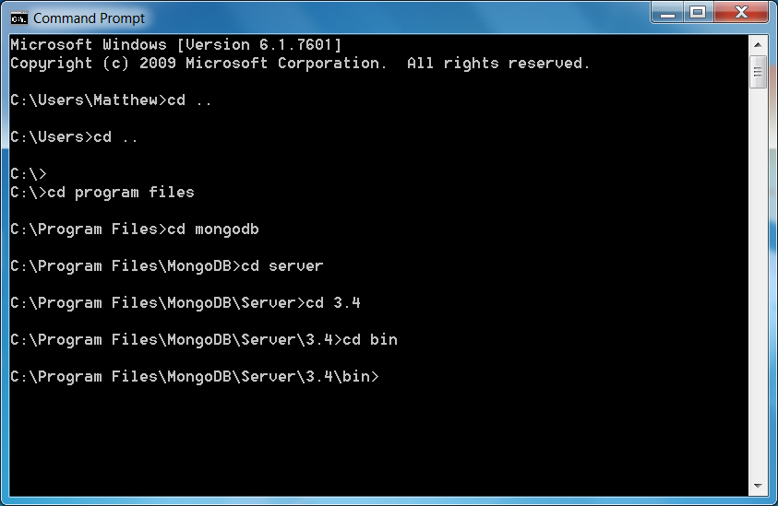

* 1. Find the directory where the data to import is saved
  2. Use the mongo line “mongoimport --db *dbName* --collection *collectionName* --type fileType --file *fileDirectory*”

(The dbName and collectionName are the database and collection names that will be created in mongo)

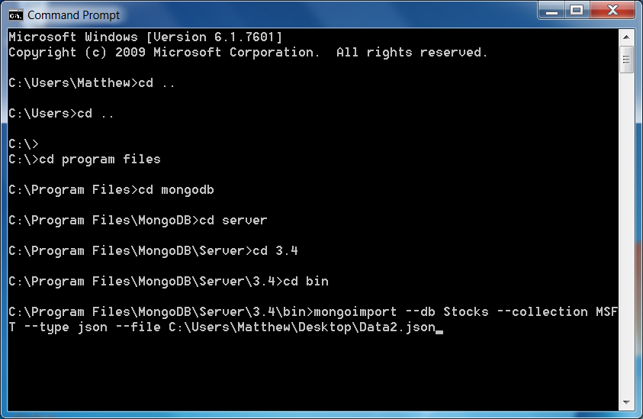

* 1. If done correctly, the command prompt should confirm that 1 document was imported to the database.
  2. Once the file has been imported, the import can be confirmed by running the following command:

**db.<collection>.find()**

* 1. Once the above command has been called, the following should appear in the command prompt:

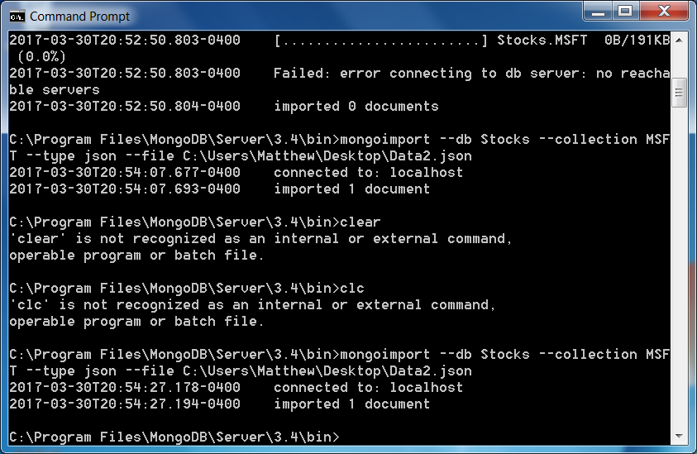

**Notes**

* The data must be slightly modified if the mongoimport tool is to be used.
  + The file importer can only import one object from the file. For this reason, if mongoimport is going to be used, go into the data file and give the array an object name.

Example:

{“ObjectName” :[ Array of JSON data that will be imported]}

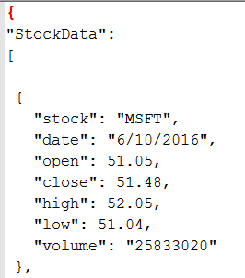

**2: db.insert Method**

For this method, the mongo command prompt shell will be used.

* 1. Navigate to the directory in command prompt where Mongo has been installed, exactly like using mongo insert.
  2. Type “mongod” or “mongod.exe” to initialize the back end of the database storage
  3. Open a second command prompt and navigate to the directory where Mongo is installed for a second time
  4. Type “mongo” or “mongo.exe” to start the mongo shell
  5. Switch to the database that you want to import the information into
  6. Type “use *dbName*”, where *dbName* represents the name of the database.

(If you have not created a database prior to this point, one will be created upon hitting enter after the “use” command)

* 1. The “use” command switches the working directory to the desired database

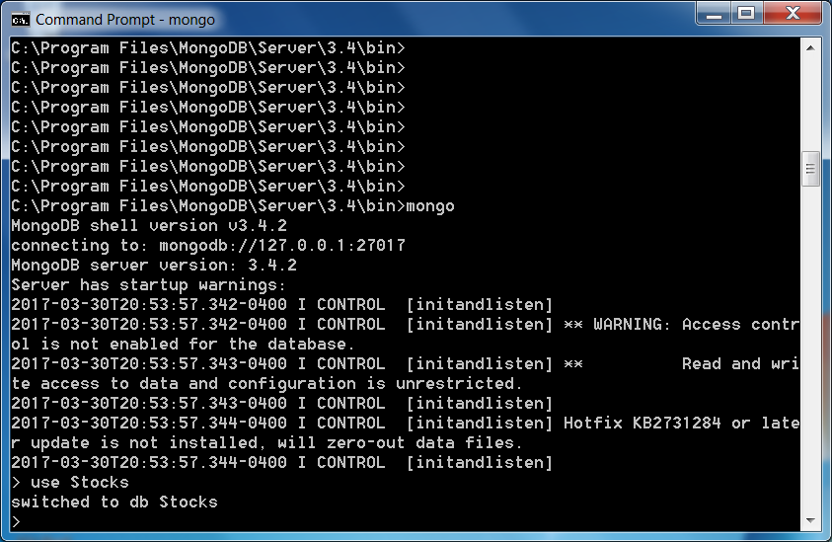

Now, use the insert command to insert the data, in JSON format, into the database

Example: db.*collection*.insert(Array of JSON data to be inserted)

* 1. The insert command must be used on an array of values. This means that for larger arrays of values that this method becomes much less practical.
  2. Once the Insert command has run its course, the data has been successfully inserted into the database under a collection

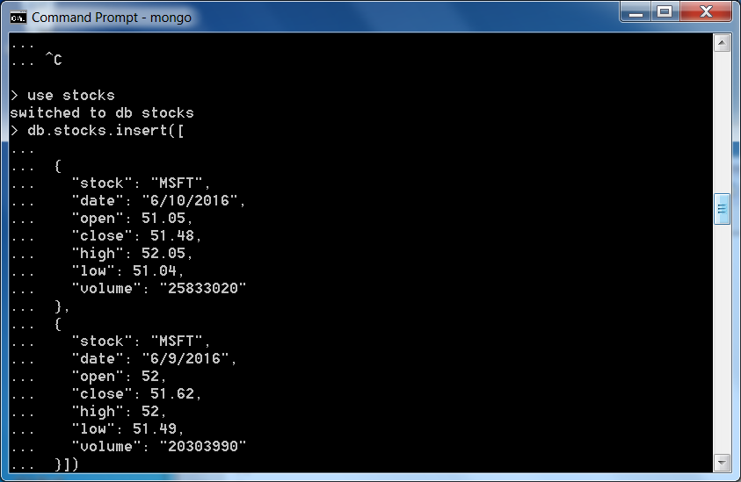

To confirm that the data has been successfully inserted, use the find function and the information should be as follows:

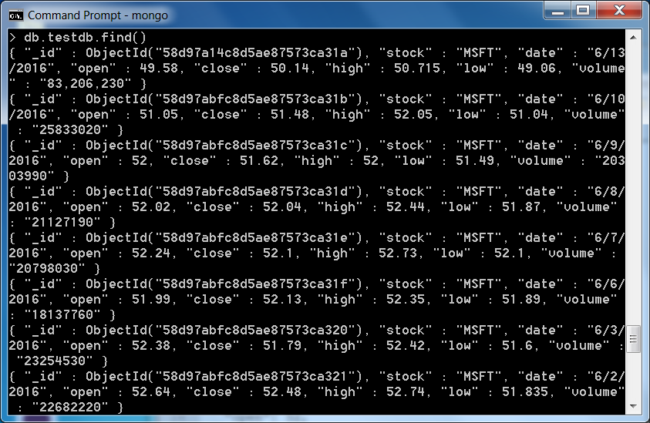

**Querying The Database:**

1. Make sure that you are in the database which you wish to query by using the “use” command.
2. Then use the find command: 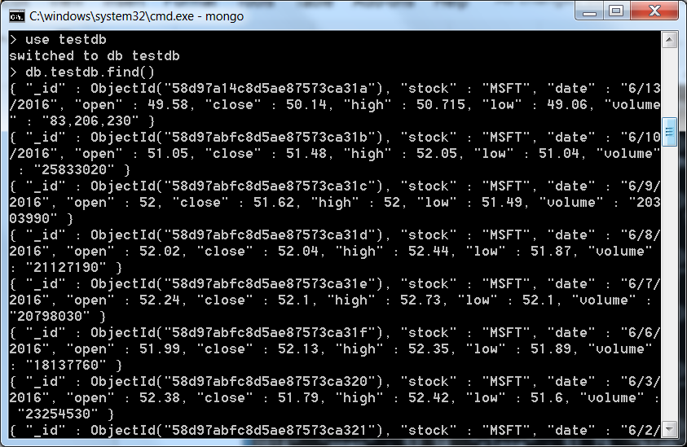 This gives a list of all data points in the database. You can specify which point by typing restraints between the parenthesis: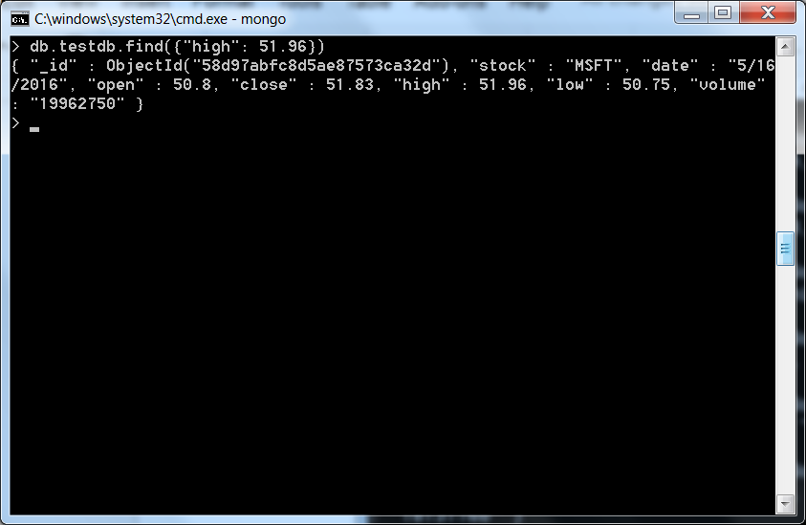

* In order to query the array of objects, which is a simplified and quicker version of importing data using mongoimport, you must use a more complicated query in order to obtain a result. The example is as follows:

