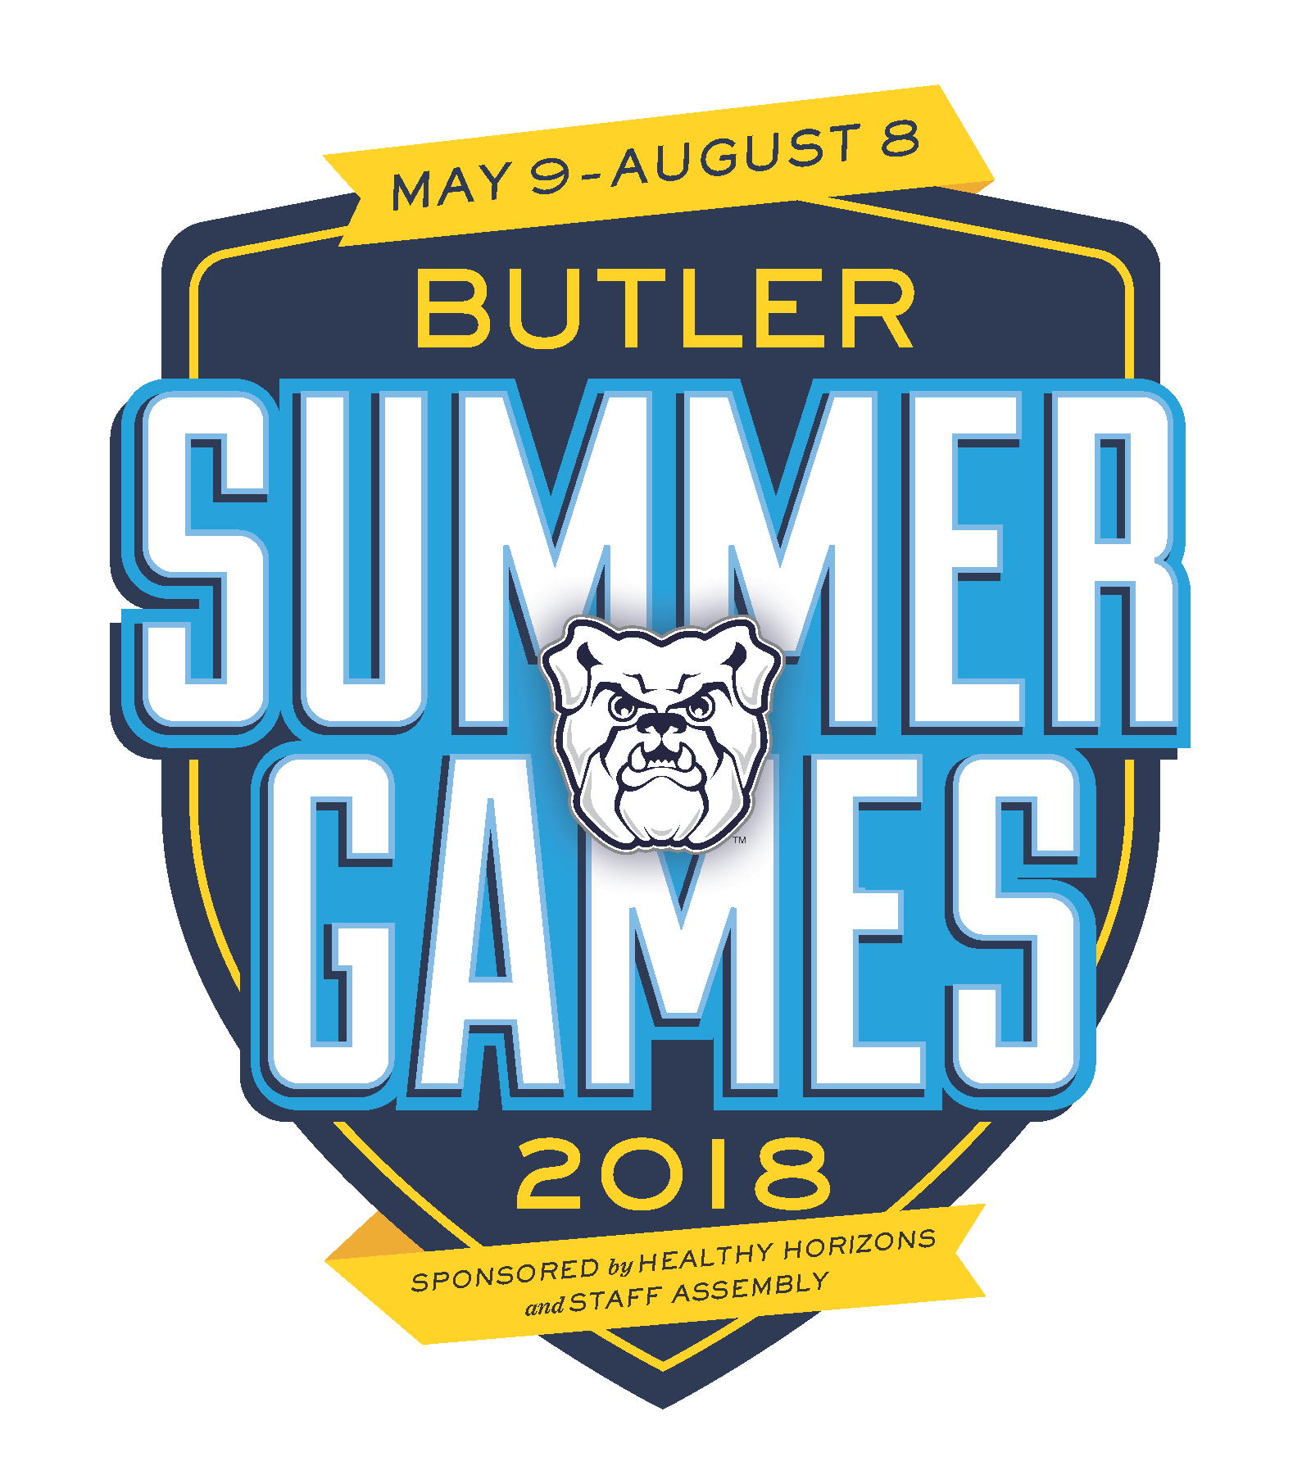

Butler Summer Games Rewards Program 2018

**http://blogs.butler.edu/healthyhorizons/**

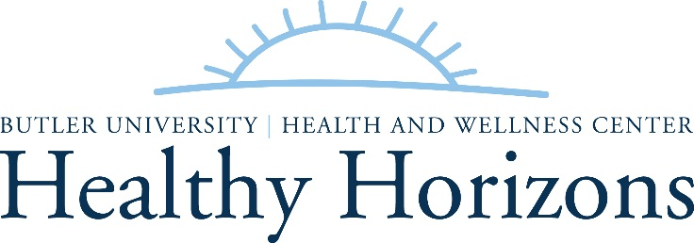

|  |  |  |  |
| --- | --- | --- | --- |
| **Summer Game Events** | **Participation Points** | **Thursday Table Games** | **Participation Points** |
| May 16: Opening Ceremonies & Duck Drop |  | May 17 |  |
| May 23: Beach Ball Volleyball |  | May 24 |  |
| May 30: 9 Square in the Air |  | May 31 |  |
| June 6: Human Foosball |  | June 7 |  |
| June 13: Giant Bananagrams |  | June 14 |  |
| June 20: Scavenger Hunt |  | June 21 |  |
| June 27: Pickleball |  | June 28 |  |
| July 4: No games |  | July 5 |  |
| July 11: Tennis Ball Golf |  | July 12 |  |
| July 18: Kickball on the Mall |  | July 19 |  |
| July 25: Corn Hole |  | July 26 |  |
| Aug 1: Water Balloon Launch v2.1 |  | Aug 2 |  |
| Aug 8: Closing Ceremonies/HRC Field Games |  | Aug 9 |  |
| **Total Summer Game Events Points:** |  | **Total Table Games Points:** |  |

**Combined Point Total:**

You may start accumulating points at any time. Bring this filled out point tracker to the Healthy Horizons office **by Aug 9** to select your prize.

Earn 20 or more points and be entered into the

**Grand Prize drawing for a Fit Bit Flex**

Winner announced August 8 at the Closing Ceremonies

**Participation Points**

**Super-fan:**

* Earn **1 point** each time you attend an event   
  & cheer on co-workers from the sidelines.

**Game-shark:**

* Earn **2 points** each time you attend Thursday Table Games**.**

**Olympian:**

* Earn **3 points** each time you attend and participate in a Summer Games Event.

**Prizes**

**Bronze: 2-14 points**

* Possible prizes: Zen Coloring Book & Pencils, Reusable Gel Pack, Magnetic Clip, First Aid Kit, Reusable Grocery Bag, Water Bottle

**Silver: 15-27 points**

* Possible prizes: Lined Thermos, Travel Pillow, Speed Jump Rope, Exercise Bands, Portion Control Product, Umbrella, Yoga Mat, Walking/Running Light

**Gold: 28+ points**

* Possible prizes: Sweatshirt Blanket, Hooded Rain Jacket, Veggie Grill Basket, Fleece Jacket, Captain’s Chair, Gym Bag, Chef Apron, Insulated Grocery Bag, Dri-Mesh Shirt (LS, SS)

HH Initial and Date: