**EPICS Healthy Horizons Survey Results**

**Background Information:**

We used Qualtrics to create a survey that would analyze the thoughts of Butler faculty and staff regarding the Healthy Horizons Rewards Program. The survey was sent out to 1262 people, and we received 233 responses. Therefore, our response rate was about 18.5%.

**Data:**

We began by gathering data about the respondents and their history with the Healthy Horizons Rewards Program.

|  |  |
| --- | --- |
|  |  |

|  |  |
| --- | --- |
|  |  |

The number of respondents that had never participated before was surprising. However, this balance was beneficial because it let us gain insight from two different perspectives: those with experience and those with fresh ideas.

Those who had never participated before were directed to a question asking whether they would be interested in doing so in the future. Because so many replied yes, the participation could likely be increased by more awareness of the program.

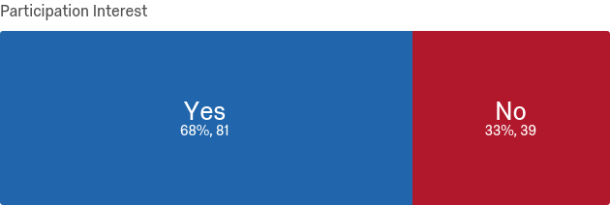

Next, respondents answered questions about the Rewards Program and its method of tracking points. Currently, participants use a paper form that can become unorganized or inconvenient. It is evident that a transition to a web application is highly desired.

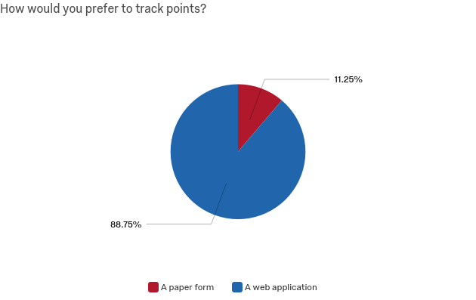

How would you prefer to track points?

Paper Form

Web Application

Despite the demand for a digital form, 64% of respondents answered that they still wanted a printable PDF of the old tracking form to be available.

To improve the rewards program for the future, we wanted to know what wellness attributes participants prioritized and what they thought of the existing objectives. As seen from the next graphic, interpersonal relationships were frequently ranked most important, while spiritual wellness was often ranked least important.

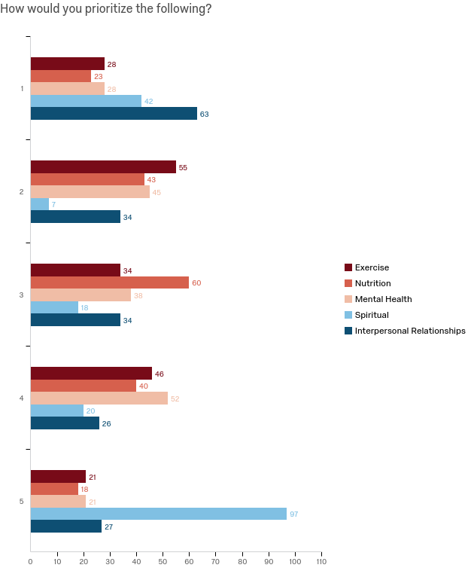

Although interpersonal relationships were prioritized the most, we found that most people hoped to improve their exercise and nutrition.

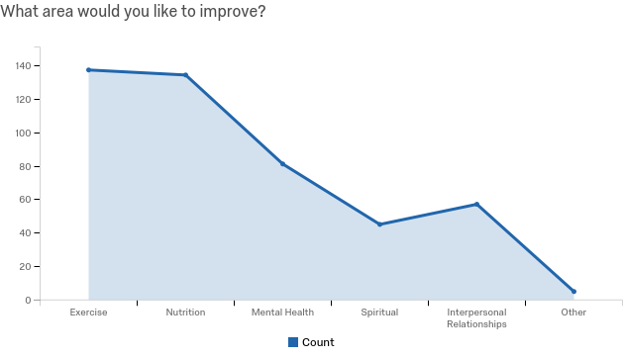

Next, respondents answered questions about the existing objectives, and those that they would like to see in the future. The table below showed us how often previous participants achieved certain objectives.

|  |  |  |  |  |  |
| --- | --- | --- | --- | --- | --- |
|  | Never | Sometimes | About half of the time | Most of the time | Always |
| Wear a seatbelt | 0.54% | 0% | 0% | 3.26% | 96.20% |
| Avoid sweetened beverages for a day | 9.19% | 14.05% | 5.41% | 36.76% | 34.59% |
| Bring a healthy lunch from home | 6.52% | 9.78% | 10.33% | 53.26% | 20.11% |
| Sleep at least 7.5 hours | 6.52% | 20.11% | 28.80% | 31.52% | 13.04% |
| At least 150min of exercise per week | 7.61% | 23.37% | 21.74% | 28.26% | 19.02% |

Because so many people always wear their seatbelt, it doesn’t seem to be a very productive way to earn points. Since the other objectives seem to be slightly more challenging, they are a better way to push people to consciously improve their health.

While thinking of making the rewards program more challenging for participants, we wanted to find out if most people were achieving platinum status. Out of the people that had previously participated in the rewards program, 44% earned over 350 points, and 36% earned between 250-349 points. The bar graph below illustrates the points breakdown among previous participants.

|  |  |
| --- | --- |
|  |  |

**For the Future:**

After learning about participants and their opinions on the current program, we wanted to gain some insight on their thoughts for the future of the program. There were some trends that appeared when we asked participants what objectives they would like to see added to the program. In order of frequency, they said:

1. Meal planning/cooking
2. Getting up from their desk/walking so many times a day
3. Attending seminars on improving aspects of wellness/guest speakers

Because having a web application gives the Healthy Horizons Rewards program more capabilities, we asked participants what they would like to see added to the program.

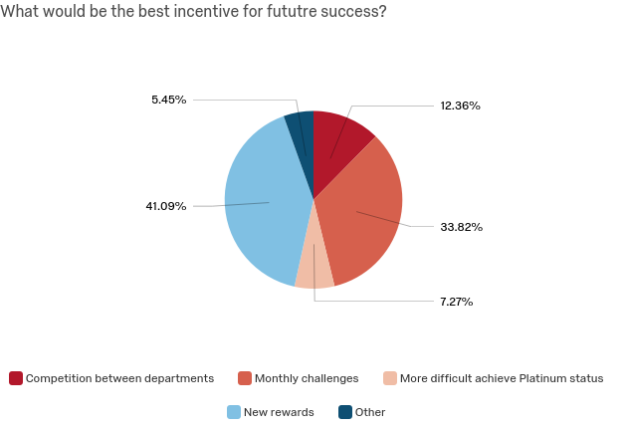

* **New Rewards:**

Respondents who answered “New Rewards” gave feedback on what prizes they would like to see added. In order of frequency, they wanted:

1. HRC gym passes
2. Gift cards to healthy places like Panera
3. Workout equipment (yoga mat, jump rope)
4. Lunchbox, cookbooks

* **Competition between departments:**

Of respondents who answered that competition would motivate them more, 76% wanted to compete in departmental teams. 88% of respondents wanted a leaderboard on the website, either their personal point or team total.

* **Monthly Challenges:**

Our hope is that in the future, the web application can be updated in real time by administrators; they could post challenges with a focus each month. 98% of people that liked this idea said that they wanted to receive notifications. This would be a great goal for future web application development. The challenges are open ended, but we wanted to gauge interest on certain topics.

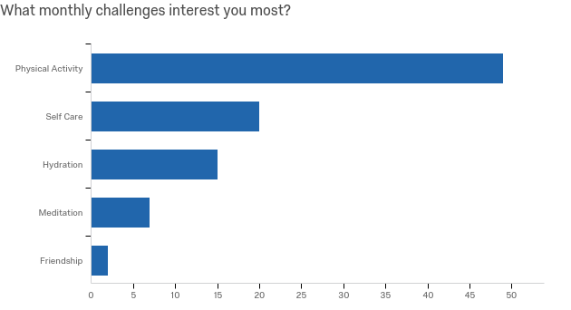

33% of people thought that the challenges should be worth 25-49 points, while 41% thought they should be worth 50-75 points.

**Conclusion:**

Overall, we were excited to see high interest levels in the Healthy Horizons. We hope to see the new web application improve the convenience and growth of the program.