

**Healthy Horizons Web Application**

EPICS

Spring 2019



Dave Purdum, Catherine Bain,

Ryan Graham, Davis Botta,

Kenneth Burton, Travis Miller,

Nick Ruddell

Table of Contents

**Introduction** **3**

**Last Semester Progress** **4**

**Project Organization and Management** **5**

**Requirement Specifications** **6**

**Architecture** **7**

**Design** **8**

**Database** **11**

# 

# Introduction

The Healthy Horizons program started in 2004 with the purpose of promoting healthy living by providing a comprehensive and confidential wellness package to Butler University faculty and staff. The program assists employees with improving their health, provides ongoing information and health education programs, and helps identify health risks and ways to reduce those risks. The program is conducted by the Health and Wellness Center, part of the College of Pharmacy and Health Sciences.

Healthy Horizons has a healthy living rewards program for Butler faculty. Participants of this rewards program accumulate points for making healthy life choices. Points are currently tracked and submitted via paper, and we worked on developing a web application to make this program run much more smoothly and hopefully attract more users.

This website was designed to expand upon the user experience, allowing users to track points each week, automatically calculate points, and select prizes all on the same portal, never having to submit anything by hand.

# 

# Last Semesters Progress

The team created a working, one time submission website. Users could log on to fill out their form, select their prizes, and then send off their results to the server. The server would write the data to a file, where it could be read by someone with access to the server.

The data was stored in local storage, or memory in the browser. This means the user's data would be loaded from the browser, and wasn’t saved in the server. A user could not log in to a different machine to view their points. Even though there was the beginning of a database at the end of Fall 2019, it was not paired with the website.

But the semester had finalized a style for the site, added different pages for viewing points and an about page, and successfully recreated the entire form submission process digitally. Now it was time to spring off that progress and create an app that didn’t just tie with the paper form, but exceed past it.

# Project Organization and Management

**Team Leader:**

● Dave Purdum

**Client Liaison:**

● Nick Ruddell

**Front End team:**

● Kenny Burton

● Davis Botta

● Travis Miller

**Back End Team:**

● Ryan Graham

● Catherine Bain

It was beneficial to split work across the different parts of the website and different technologies. As long as there is a consensus across what the goal of the team as a whole should be, splitting up groups based on languages

* CSS
* HTML
* Javascript (DOM)
* Node.js
* SQL

and client-side versus server-side was best for the project.

# Requirement Specifications

Our client asked us to create a website that will allow users of the Healthy Horizons program at Butler University to submit healthy habits using a technological solution instead of manually submitting a paper form. The Healthy Horizons program allows Butler faculty to earn points to redeem for rewards by incentivising good dieting habits. For example, faculty can track the number of times they go to the gym, the number of steps taken a day, or attendance at meditation classes at the HRC. At the end of the semester, faculty can fill out a form that equates good habits with points, that can in turn be redeemed for different tiers of rewards.

Our client asked for an alternative to the current point submission. Before this project began, users need to fill out a paper form that tracks all healthy habits done for the entirety of the semester. Then, the faculty member has to manually calculate the number of points each of their habits earns, and then sum the total points. Then the papers need to be logged electronically after submission for internal use by Butler.

The client wanted a better solution. Users should be able to log their points electronically, have an application automatically calculate points for each habit, and also allow easy changes to the current set of goals offered by Healthy Horizons. Furthermore, a survey was constructed to get feedback from the faculty about the current points listed in the form, as well as interest in an electronic alternative.

We opted for a web-based solution. A website could allow any user on any device to access a web form that can allow users to track healthy habits as they complete them, and further submit points at the end of the semester. This way everything could be done electronically without paper submissions. Furthermore, a website is a good foundation for future features and changes made to the Healthy Horizons program.

# Architecture

Our goal was to create a website that would allow users to view and save information onto a server. We would host a server that stored persistent data, that is, web pages, images, and user data. Then a host, using a mobile device or computer, would access the server by making a request through a web browser. The client-server relationship is the fundamental feature of the architecture.

The server uses Node.js, a server-side language that expands on the javascript capabilities that are typically limited by web browsers. Node.js is a brand of javascript that can handle things like reading files, querying databases, and handling HTTP requests that web browsers can’t do. We run this Node.js so that the client can query it for information. This information includes web pages, style sheets, scripts, and resources such as images.

The client uses a web browser such as Chrome or Firefox on any device: computer or phone. These web browsers create an HTTP request to “get” web pages from the server. It will also get any style sheets, logic, or images also on the server. There are three languages that a browser can interpret: HTML, CSS, and Javascript.

HTML describes the content on the page, and how it is structured. For example, the content inside titles and paragraphs are stored in HTML pages. Information, such that a button might be inside a paragraph, which could be inside a side panel on the page, is also stored here. However, how that information appears to the user is handled in a CSS file, or a style sheet. It describes the color, height and width, location, and other attributes related to each of the elements of the page. Finally, there are Javascript files that describes how the user interacts with what is on the page. It handles parsing data, performing calculations, and manipulating elements on the screen based on events that may have been called by a button press or internal function. In addition, we used a template language called EJS. Effectively it allows for a set of styles or objects to exist across several web pages. This allowed us to have a more effective navigation bar along with unified style of the pages rather than explicitly defining the style on each webpage.

# Design

The design of the website was created using CSS and HTML. We did not want to have complex webforms. We choose to stay simple with the design.

At the top of each of our webpages, there is a navigation bar with tabs to link to other pages on our website. This might be removed later, but serves as a quick place to jump between parts of the site.

The about page is just an overview of Healthy Horizons. It gives a description of EPICS and explains who developed the site. It also gives general instructions on how to navigate and use the site.

The calendar page is where all the functionality in the app lies. It allows users to see and update their progress.

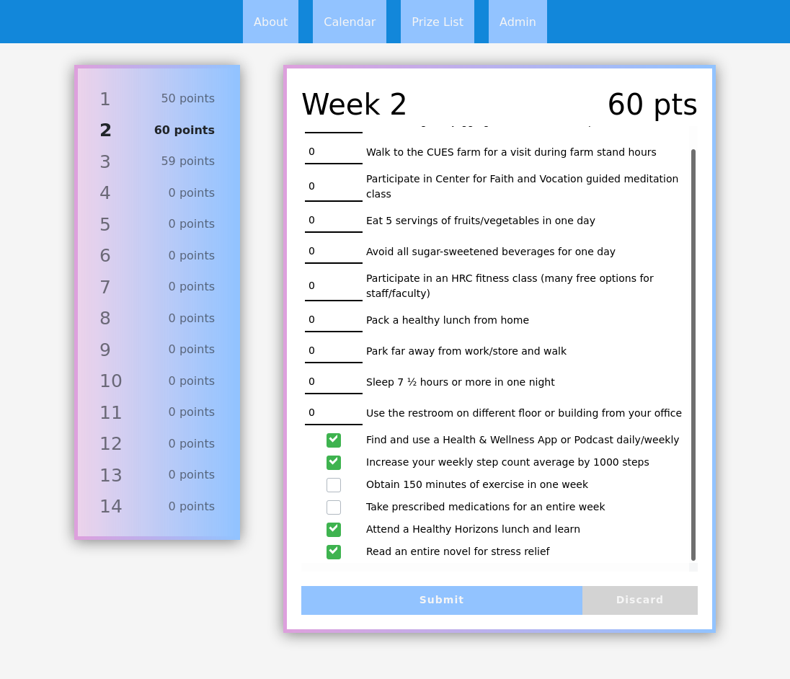

The select prizes page allows you to select your prizes. It only will reveal which prizes you are able to select. If you do not have enough points for Gold tier, it will not show that tier. If you aren’t silver tier, the page doesn’t allow you to do anything, and sends you back to the main page.

There is also an admin page that shows a summary of users in the database, the number of points they possess, and which prizes they have selected that semester.

# 

# Database

The database was created in MySQL and is accessed by a separate Node.js file. The database and Node.js file were completed separately from the Healthy Horizons backend. Here is a schema for the site as it is.

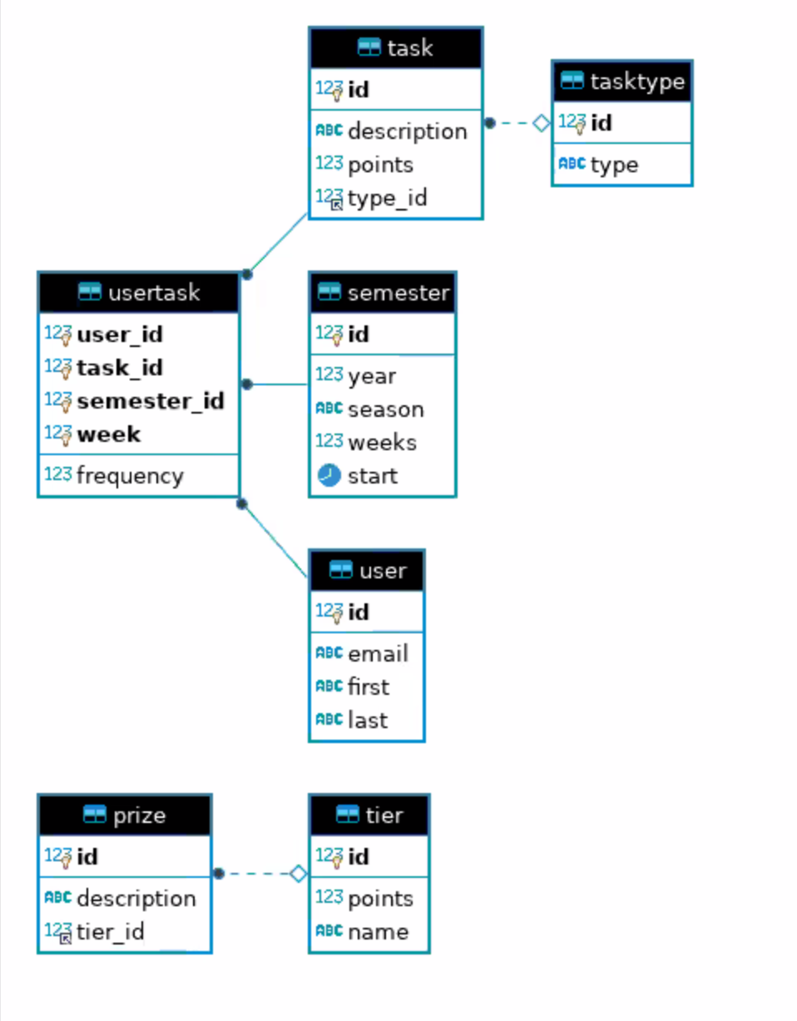

The user table holds the name and email of users, and in the future can store a key or token needed for Auth0. The semester table outlines which semester is happening, including the year, season, the number of weeks in that semester, what the start date is. This allows it to be used over the summer months too, when things are a bit different.

The task table and task type table describe the different tasks users can complete, as well as how often the user should be able to complete them: daily, weekly, or per semester. Usertasks joins all the previous tables together, and is where all the user inputted data is stored.

Lastly we have prize and tier tables that store the different prizes in the database and the point thresholds for each tier.