First, download the SQL Server Management Studio (SSMS) from the following website:

<https://docs.microsoft.com/en-us/sql/ssms/download-sql-server-management-studio-ssms?view=sql-server-ver15>

Install it using the default settings through the installation wizard.

To run it, go to this place in your file explorer:

C:\Program Files (x86)\Microsoft SQL Server Management Studio 18\Common7\IDE

Look for “Ssms”. It should be of file type “application”. After running it, you should be presented with this screen:

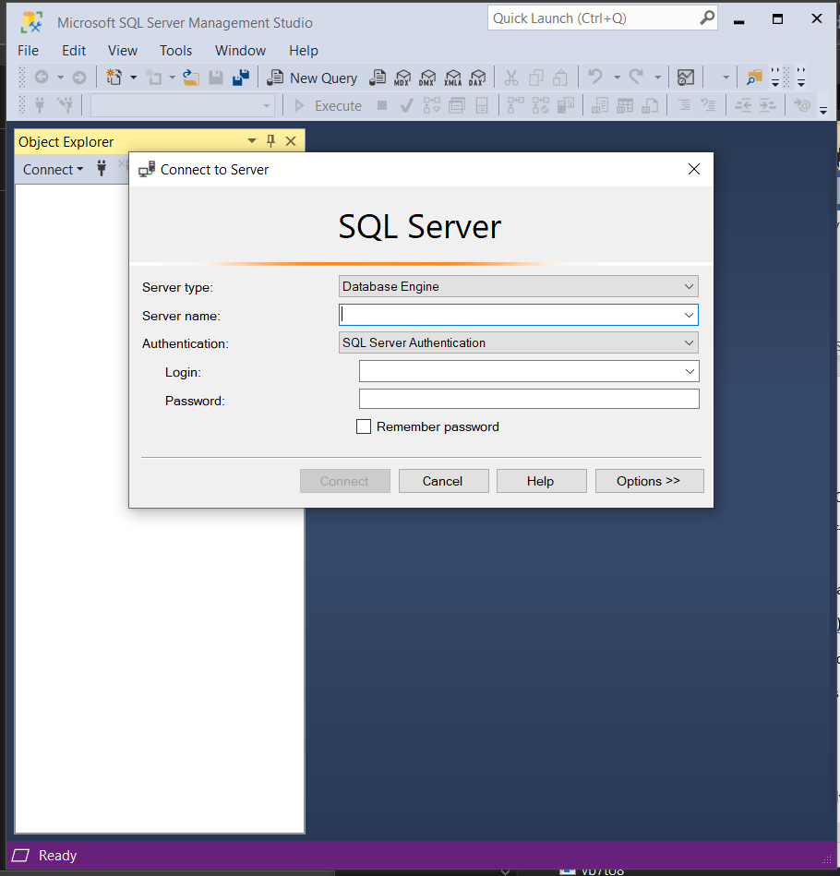

In the server name, input the “Full Server Name” given in the Azure Server Information block below. The login and password should be the Server Admin info also in the Azure Server Information block.

After that, you should be logged into the database and can expand Databases to see the “ISHAA Development Database”. From there you can expand “Tables” and see what the database contains. To see what is in the tables, right click the table you want to view and click “Select Top 1000 Rows”.

I am not familiar with this app too well yet, so if there are any questions about using it or setting it up message Kameron Leisure on discord.

Azure Server Information:

- Server Name: ihsaa-development-server

- Full Server Name: ihssa-development-server.database.windows.net

- Server Admin Username: DevelopmentAdmin

- Server Admin Password: DevelopmentPassword2021

Probably not useful:

- Subscription Resource Group: IHSAA-Development-Resources