**Setting Up and Editing an Azure Database Server:**

Setting up the Azure Database:

* Start by making a database here:

[Use a fast NoSQL database to build applications with your Azure free account | Microsoft Azure](https://azure.microsoft.com/en-us/free/cosmos-db/search/?OCID=AID2100131_SEM_3b8912eccc6e1e9292f6728ef76c0d74:G:s&ef_id=3b8912eccc6e1e9292f6728ef76c0d74:G:s&msclkid=3b8912eccc6e1e9292f6728ef76c0d74)

* IMPORTANT: THIS IS A FREE VERSION OF AZURE, YOU WILL NEED TO UPGRADE WITHIN 2 MONTHS. The upgrade is a “pay-as-you-go” subscription, meaning that Microsoft should not take money out of the account associated with it UNLESS a service is used that costs money. MAKE SURE TO PICK A RESPONSIBLE DATABASE ADMIN, AND BE CAREFUL WITH WHAT YOU USE
* As you fill out data entries, save items that will be important- the attached file at the end are the entries we used during the project
  + MAKE SURE TO MAKE THE ADMIN USERNAME AND PASSWORD AMBIGUOUS, OTHERS WILL USE IT FURTHER ON
* You will need to create a Resource Group
  + In the search bar at the top of the screen (it should say “Search resources, services and docs” in it), type in “Resource groups”
  + Select the “Resource groups” service
  + In the top corner of the page, click “Create”
  + Enter information as needed, and make sure to save it in a text file as you go, the document at the end of this should provide some reference as to what to save
* For the following steps, when something asks for a resource group, use the one you just made
* You will need to create a SQL Server
  + In the search bar at the top of the screen (it should say “Search resources, services and docs” in it), type in “SQL servers”
  + Select the “SQL servers” service
  + In the top corner of the page, click “Create”
  + Enter information as needed, and make sure to save it in a text file as you go, the document at the end of this should provide some reference as to what to save
* You will need to create the database
  + At the top of the Azure Home page, there should be a button called “SQL Databases” under Azure Services, select it
  + After clicking it, click “Create” in the top left corner of the new screen.
  + Fill out items as needed, but settings should remain default as much as possible

You should now have a named SQL Server and Database.

Adding New Wifi Hotspots to the database:

* Before allowing others to access your database, you will have to add every wifi hotspot you will be accessing the data from to the Azure Portal. A very important one will be the Butler Secured wifi hotspot.
* Go to the Azure Portal and select your server. NOT THE DATABASE
* On the left, scroll down until you reach the “Security” section. Click “Firewalls and virtual networks.
* On this page, you will see a table with the columns “Rule Name, Start IP, End IP”
  + Make the name of the WIfi the rule name, formatting is not important
  + For the Start and End IP, have the user go here:

[What is my IPv4? - Show IP address (what-is-my-ipv4.com)](https://www.what-is-my-ipv4.com/en)

* + Add the IPv4 given at the top of the screen to both Start IP and End IP columns
  + Click “Save” at the top of the screen
  + The wifi hotspot should now be able to access the database
* This can be repeated as needed, and whenever you wish

**The following directions can be performed by anyone wanting to access the database**

Next you will need to install SSMS (SQL Server Management System)

* This link should let you download the application:

https://docs.microsoft.com/en-us/sql/ssms/download-sql-server-management-studio-ssms?view=sql-server-ver15

* MAKE SURE TO USE DEFAULT SETTINGS AS YOU CONTINUE THROUGH THE INSTALLATION WIZARD
* To run the application, first go to

C:\Program Files (x86)\Microsoft SQL Server Management Studio 18\Common7\IDE

In your file browser. Then find the “Ssms” file. It should be an “application” type. Run it.

* You will be presented with this screen: 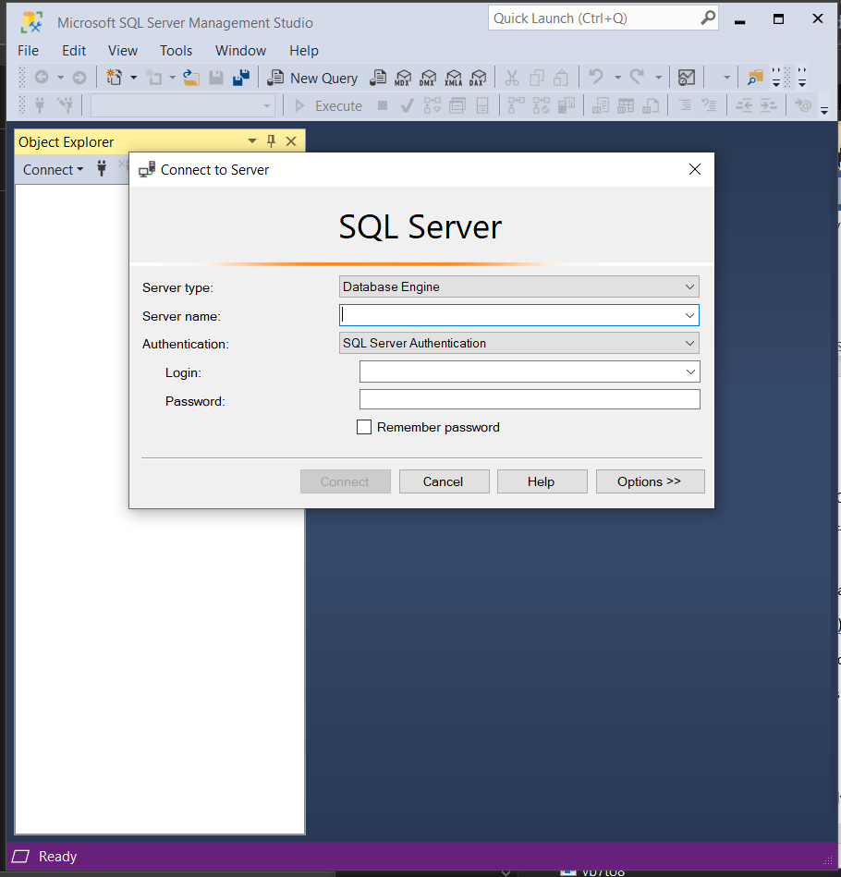
* In the server name, input the “Full Server Name” saved by the admin
* After that, you should be logged into the database and can expand Databases to see the name of the database. Expand it
* From there, right click “Tables” and go to new. From here you can create new tables in the database
* You will also want to import data given by the client. To do this, right click the database name. Go to tasks and import data. Follow the wizard.
  + When selecting information to import, the wizard really likes “Microsoft Excel 97-2003”. Other Microsoft files will require extra software to be downloaded. This we will have to leave you to research
  + When you reach the “Choose a destination” tab, select “SQL Server Native Client” and select “Use SQL Server Authentication”. Fill out admin credentials
  + Leave the rest of the settings as normal in the wizard
* The table should show up when the “Object Explorer” is refreshed

Final note: These applications are all well documented, so if errors occur a little research should be needed to fix the issue.

Where we left off:

* We were considering using an HTTPS connection to connect the app to the Azure Database. From what we had researched, it would need the use of HTTPS and SQL logic gates in the Portal itself. More research will be needed, if this is a viable route.

**Azure Database Example Info:**

Note: The following resources belong to a subscription that no longer exists, if you wish to copy them, do so.s

//Useful for everybody

Azure Server:

- Server Name: ihsaa-development-server

- Full Server Name: ihssa-development-server.database.windows.net

- Server Admin Username: DevelopmentAdmin

- Server Admin Password: DevelopmentPassword2021

//Probably not useful for everybody

- Subscription Resource Group: IHSAA-Development-Resources